Task one

1st website URL;

[www.fitnessfirst.co.uk](http://www.fitnessfirst.co.uk)

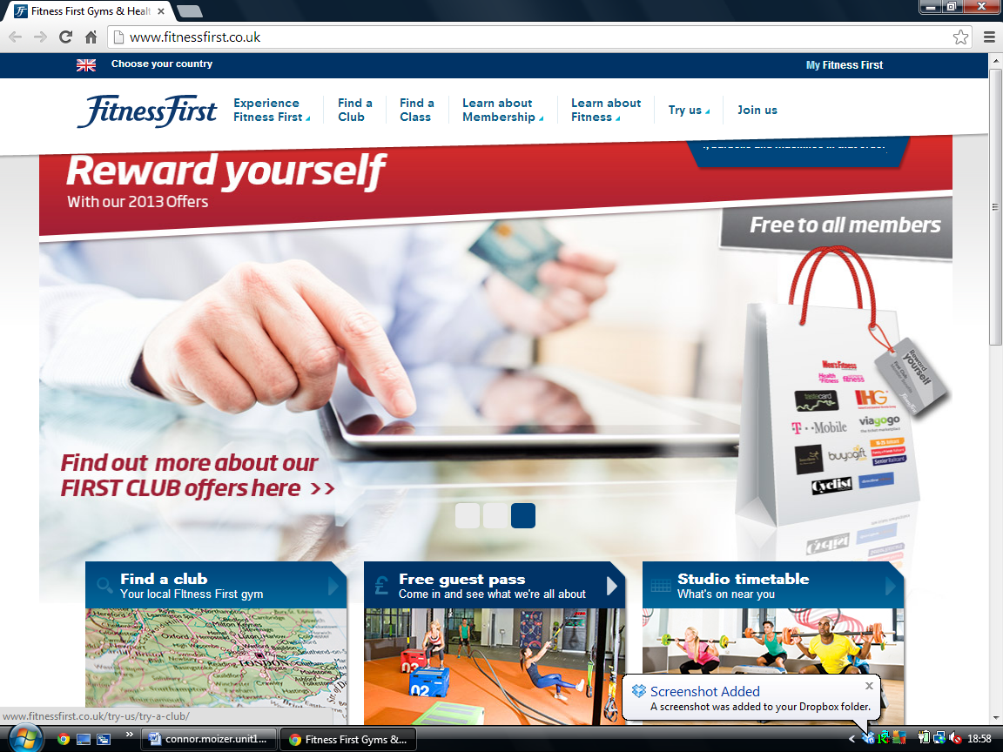

|  |  |
| --- | --- |
| Featchers | usage |
| rolling Imagers | To catch people attention c1 |
| Hyperlinks with drop downs | to give you more options c2 |
| scrolling banners | to keep up to date with gym news c3 |
| change the country | different parts of the world c4 |
| imagers with text | explains the imagers with text c5 |
| sections | more options c6 |
| Maps | Find where local club is c7 |
|  |  |